PRACTICE SESSION 8

CLASS BATCH 131

Time: 90 minutes

**Question 1.** Using HTML5, CSS3 create a website as pictured below:

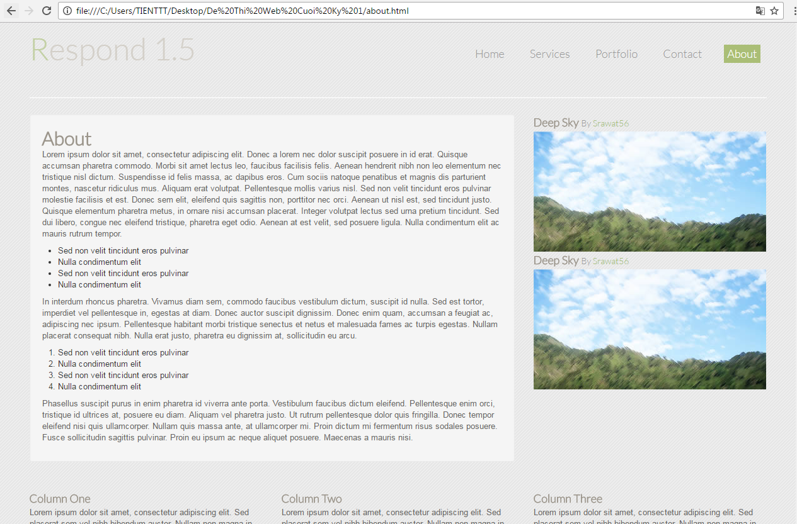

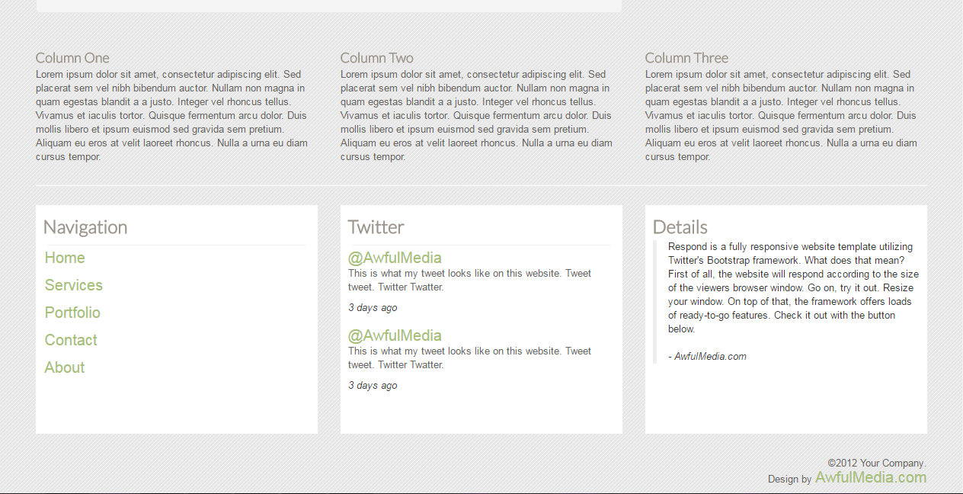

with the photos are taken in folder images.